Sleep Apnea with Inspire
What is Inspire® therapy?
Inspire therapy is a mask-free solution for people with obstructive sleep apnea (OSA) who have tried and struggled with CPAP. Through a simple-to-use system including the Inspire® implant, Inspire™ remote and Inspire® app, Inspire therapy enables you to control your OSA treatment from the palm of your hand.
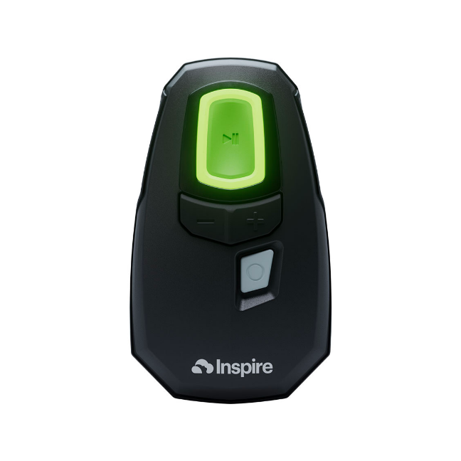
How does Inspire therapy work?
During sleep, your tongue relaxes. For people with OSA, your tongue relaxes into a position that blocks your airway. While other OSA therapies use a hose and mask to force air through your airway, the Inspire implant works comfortably inside your body to sense when you take a breath. Then, it delivers gentle pulses that move your tongue forward to keep your airway open, helping you breathe regularly and sleep soundly. Simply use the small handheld Inspire® remote to turn your therapy on when you’re ready to sleep.
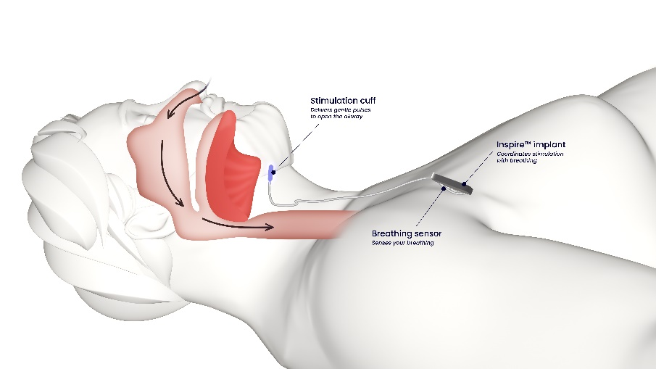

(“Inspire system with arrows” image)

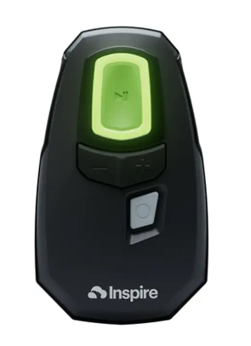
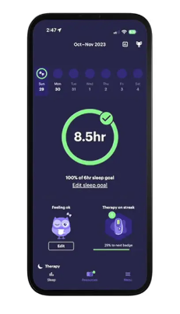
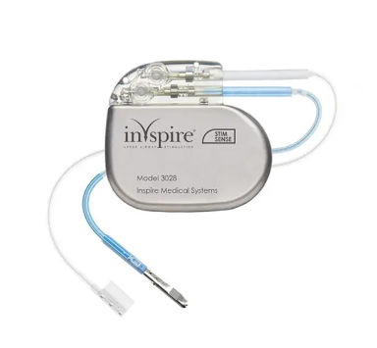

The Inspire implant keeps your airway open while you sleep, so you can breathe regularly and sleep soundly.
The handheld Inspire remote simply turns on your therapy when you’re ready to sleep. No mask or hose required.
The Inspire app tracks your sleep goals and allows you to share data directly with your doctor.

Is Inspire therapy right for you?
To be a candidate for Inspire therapy, you must meet the following FDA indications:
- Age 18 or older
- Diagnosed with moderate to severe OSA
- Have tried and struggled with CPAP
Effectiveness of Inspire Therapy
Does Inspire therapy really work? Inspire is a safe and effective therapy with 10 years of FDA approval. According to recent studies:

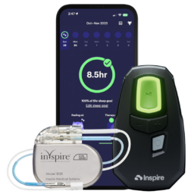

- 90% of bed partners reported no snoring or soft snoring
- 91% of people are satisfied with Inspire therapy
- Patients had a 79% reduction in sleep apnea events
- 94% of patients say Inspire therapy is better than CPAP and would recommend it to others
Get Started!
The first step is to schedule a consultation with our team. We’ll discuss your current therapy, provide details on Inspire therapy and answer your questions.
Contact our office today! 480-614-0499

